Ventilation model

Key to symbols

|  |  |  |
| --- | --- | --- |
| **Symbol** | **Description** | **Units** |
| *ρ* | air density | kg m-3 |
| *a*min | Minimum height of ventilation aperture, expressed as a proportion of *H*max | - |
| *A*plan | plan area of housing | m2 |
| *A*wall | total surface area of wall | m2 |
| *C* | specific heat of the air | J kg-1 K-1 |
| *f*sens | proportion of *Q*tot that is sensible heat |  |
| *h* | wall height | m |
| *H*max | Maximum average vertical opening of ventilation apertures | m |
| *k*s | parameter used to account for the sensible heat converted to latent heat through evaporation of water outside the animal |  |
| *Q*sens | sensible heat output | W |
| *Q*sup | Supplementary heating (force-ventilated housing) | W |
| *Q*supmax | maximum heating capacity of the housing (force-ventilated housing) | W |
| *Q*tot | total heat output per animal | W |
| *T*max | Maximum acceptable temperature (naturally-ventilated housing) | K |
| *T*min | Minimum acceptable temperature (naturally-ventilated housing) | K |
| *T*o | outside air temperature | K |
| *T*targ | target inside temperature (force-ventilated housing) | K |
| *U*roof | thermal transmissivity of the roof material | W m-2 K-1 |
| *U*wall | thermal transmissivity of the wall material | W m-2 K-1 |
| *V* | Ventilation rate | m3 s-1 |
| *V*max | maximum ventilation rate | m3 s-1 |
| *V*min | minimum ventilation rate | m3 s-1 |
| *v*opt | Adequate air speed to provide a safe and comfortable environment for both humans and livestock (naturally-ventilated housing) | ms-1 |
| *W*tot | Total width of ventilation apertures (naturally-ventilated housing) | m |

# Introduction

The objective of ventilation is to maintain the temperature in the animal housing at a level that is commensurate with the health and welfare of the animals and of the humans involved in livestock husbandry. The fluxes of energy in animal housing are:

1. The energy generated by the livestock.
2. Solar energy entering via the roof and walls.
3. The flux of energy generated in the roof and walls as a result of differences between the inside and outside temperature.
4. The flux of energy resulting from the exchange of inside and outside air.
5. The flux of energy generated between the housing and the earth beneath it (the ground heat flux).

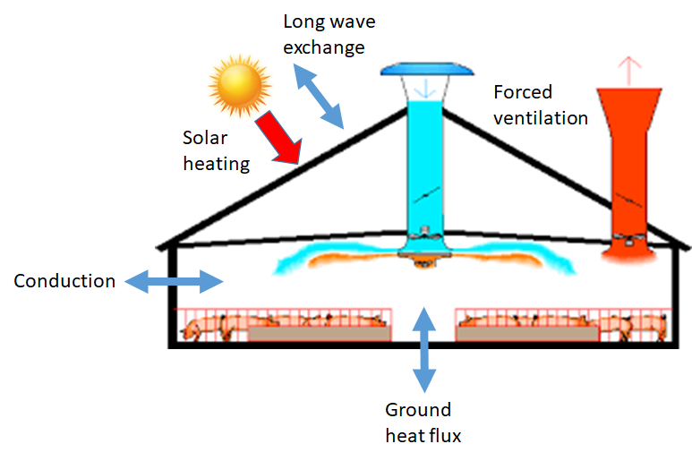

Fig 1 Forced (controlled) ventilation housing

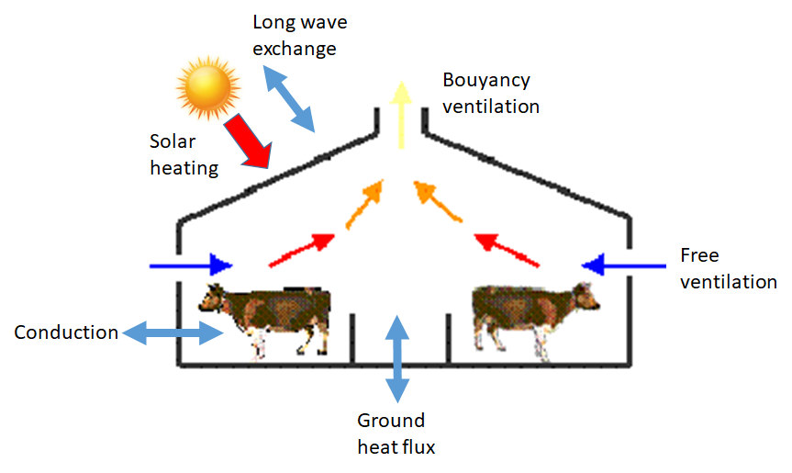

Fig 2 Freely-ventilated housing

The first two sources are always positive (i.e. contribute energy to the housing) whereas the other three can be positive or negative (although the ventilation air rarely so). Here, we focus on the first four sources, since the ground heat flux tends to be a minor element in the overall energy budget.

The energy in the air can be in two forms; as sensible heat (the energy that contributes to air temperature) or as latent heat, which is the energy stored in water vapour. The total heat output per animal (*Q*tot; W) is an input for both controlled and natural ventilation. This can either be obtained as a standard value or calculated as a diet- and climate-dependent value from the energy balance of the livestock. The sensible heat output (*Q*sens; W) is calculated by estimating the proportion of *Q*tot that is sensible heat (*f*sens):



(Pedersen and Sällvik, 2002) provides a method for calculating the sensible heat from an estimate of the total heat production, using a non-SI unit (heat production unit). *f*sens is calculated by reworking the relationship given in the CIGR report of 2002:



Where *k*s is a parameter used to account for the sensible heat converted to latent heat through evaporation of water outside the animal (e.g. wet floors, moist animal feed) and *T*i is the inside temperature in Kelvin. Here we assume that the flooring is always wet, so *k*s = 0.85. Since *T*i is unknown at the start of the calculation, we make the assumption that for housing with controlled ventilation, assign *T*i to the target temperature for the housing (*T*targ ; Kelvin) whereas for freely-ventilated housing, we assign *T*i to the outside temperature (*T*o; Kelvin). This introduces some bias in the estimate but since the difference between *T*i and *T*targ or *T*i and *T*o rarely exceeds 4-5 Kelvin, it is deemed acceptable.

# Model definition

The model is mainly based on the animal house model of Cooper et al (1998). The major simplification made in comparison with Cooper et al (1998) is that the building is considered to be square in plan, with a flat roof and no account is taken of the orientation relative to the compass. The notation used here is from (Cooper *et al.*, 1998), with minor modifications.

The animal house is defined in terms of the average length of the walls (*d*; m) and the average wall height (*h*; m). The total surface area of wall (*A*wall; m2) is then:



For a cubic house, the floor area and the roof area are identical (*A*plan; m2):



The aim of the ventilation is to maintain the inside temperature within acceptable limits. Generally, ruminant livestock are kept in freely-ventilated housing whereas other types of livestock (e.g. pigs and poultry) are generally kept in housing with forced (fan-driven) ventilation, with the facility to provide supplementary heat if necessary. In both cases, a minimum level of ventilation is desirable, for health and welfare reasons. Conversely, there will be for both types of housing, a maximum ventilation rate that is determined for freely-ventilated housing, by the conditions inside and outside the housing and the maximum size of venting apertures and for forced ventilated housing, by the maximum capacity of the fans. The model therefore needs to determine:

* The ventilation rate, when a desirable inside temperature can be achieved with a ventilation rate between the minimum and maximum values.
* To what extent the inside temperature falls below a desirable value, when conditions demand that the ventilation rate must be at the minimum value.
* To what extent the inside temperature exceeds a desirable value, when conditions determine that the ventilation will be at the maximum value.

The flux of sensible heat from the livestock has been described earlier. The flux of sensible heat from the environment is determined by the solar and long-wave radiation, where the latter can be contribute or remove heat from the housing. The solar radiation input is equated here to the meteorological solar radiation (S; W) and we assume here that it is only intercepted by the roof. The housing emits long wave radiation to the surrounding environment and absorbs long wave radiation emitted by the surrounding environment. We assume here that the temperature of the walls of the housing are sufficiently similar to that of the surrounding landscape that there is no net exchange of long wave radiation between them. The net long wave radiation between the roof and the sky (*L*; Wm-2) is determined using the Stephan-Boltzmann equation to estimate the upward long wave radiation from the roof and the downward long wave radiation from the sky. Subtracting the former from the latter:



Where σ is the Stephan-Boltzmann constant, *e*house is the emissivity of the surface of the housing (a model parameter) and *e*sky is the effective emissivity of the sky, determined using the relationship developed by (Brutsaert, 1975).

Using the same construction as (Cooper *et al.*, 1998), a variable *T*sol (K) is defined as the air temperature which, in the absence of solar radiation, would give the same temperature distribution and rate of energy transfer through a roof as that which exists with the actual air temperature and incident radiation:



Where *a* is the coefficient of absorption of solar radiation (dimensionless) and *I* is an external surface resistance (m2 K W-1). Both *a* and *I* are model inputs.

## Forced ventilated housing

Whether the task is to determine the inside temperature for a given ventilation rate or the ventilation rate for a given inside temperature, the equation to be solved is one form of the following equation:



Where *U*roof and *U*wall are the thermal transmittances of the roof and walls respectively (W m-2 K-1), *C* is the specific heat of the air (J kg-1 K-1), *ρ* is the air density (kg m-3) and *V* is the ventilation rate (m3 s-1). The first compound term describes the transport of heat in ventilation air and the second compound term the heat flux through the walls and roof of the housing.

If the outside air temperature is below the target inside temperature, then Equation can be rewritten as follows, if the inside temperature is to be maintained at *T*targ.



where *V* here is the ventilation rate required to maintain *T*targ. The simplification relative to Equation 10 of (Cooper *et al.*, 1998) is that all walls are assumed to have the same thermal properties and have a surface temperature equal to the outside temperature. We consider this an acceptable simplification because:

* Only one or two walls would normally be illuminated by the sun, so the remainder would have a surface temperature close to the outside air temperature.
* Housing with controlled ventilation will often have relatively well insulated walls, due to the need to reduce the use of supplementary heating during cold weather, so the heat flux through the walls will be relatively minor.

Note that we make the same simplification as (Cooper *et al.*, 1998) insofar as we ignore the difference in *C* and *ρ* due to the difference between the outside and inside temperature and humidity.

By reorganising Equation , *V* is given by:



If *V* is calculated to be greater than the maximum ventilation rate of the extraction fans (*V*max; m3 s-1), or *T*o*>=T*targ, *V* = *V*max and the temperature inside the housing (*T*i; K) will exceed *T*targ. *T*i is then given by rearranging Equation :



Alternatively, if the value of *V* calculated by Equation is below the minimum ventilation rate (*V*min; m3 s-1), *V* = *V*min and supplementary heating *Q*sup (W) is applied in order to maintain the target temperature. *Q*sup is given by:



If the supplementary heating necessary to maintain *T*targ exceeds the maximum heating capacity of the housing (*Q*supmax; W), the inside temperature is given by Equation , replacing *Q*sens with (*Q*sens+*Q*supmax). In this case, *T*i will fall below *T*targ.

## Freely ventilated housing

With freely-ventilated housing, the farmer manages the environment by opening/closing apertures in the walls or roof. The ability of the farmer to control the environment in the housing depends on their objectives, the construction of the housing, the livestock kept and the climate. Most freely-ventilated housing has some apertures that can be controlled (e.g. windows, blinds, roof vents) and a proportion that cannot (e.g. weatherboarding). For simplicity, we assume that:

* The housing is cubic, as for the controlled ventilated housing.
* The ventilation apertures are all in the walls and that the ventilation is controlled by adjusting the vertical extent only.
* The wind strikes only one side of the housing and does so at an angle of 90º.

The ventilation aperture is defined in terms of a mean width (*W*; m), a mean maximum vertical opening (*H*max; m) and a mean minimum extent of the aperture in the vertical dimension, expressed as a proportion (*a*min) of *H*max. Note that *W* is the sum of aperture widths on all sides of the housing. For housing with no walls, *W* = *d* and *H*m*ax* = *h*.

The heat fluxes in freely ventilated housing consist of the flux through the walls and roof of the building, the wind-driven ventilation and the buoyancy-driven ventilation. The flux through the walls and roof are analogous to those described for controlled ventilated housing above, though here the area of surface will vary as well as the temperature difference, since the opening of the apertures in the walls will vary. The wind-driven ventilation is analogous to the forced ventilation, except that the air velocity is not controllable. The final term is due to the effect of the heat generation by the animals on the buoyancy of the air in the housing.

The ventilation and inside temperature for freely ventilated housing follows Cooper et al (1998), in which the ventilation rate is determined by solving the following cubic function analytically.



Where *c*, *ρ* and *Q*sens are defined as for controlled ventilated housing and the remaining variables are defined as follows. The total ventilation (*V*t; ms-1) is:



where *V*n (ms-1) is the air flow caused by buoyancy and *V*f (ms-1) is the air flow caused by the wind. *V*n is defined as:



where *C*d is a discharge coefficient (evaluated to 0.6), *g* is the gravitational constant (m s-2) and *ΔT* is given by:



*V*f is defined as:



where *u* is the wind speed (ms-1).

The construction UA is defined as:



The variable *q* is defined as:



where *ΔT*sol is defined as:



The construction *B* is defined as:



In contrast to the situation with forced-ventilated housing, the criteria used by farmers when controlling ventilation is less clear. Here it is assumed that to provide a safe and comfortable environment for both humans and livestock, the farmer wishes to achieve the following:

* The inside temperature should remain above a specified minimum, *T*min (K), to prevent cold stress and avoid floor surfaces becoming icy.
* The inside temperature should remain below a specified maximum value, *T*max (K), to avoid heat stress among livestock and workers.
* To maintain the air velocity at some specified value, *v*opt (ms-1), which reduces the viability of disease organisms and provides a pleasant environment for livestock and workers.

If meeting all these objectives simultaneously is not possible, the assumption is that the temperature criteria are prioritised over the velocity criterion.

Step 1 If the housing does not have adjustable ventilation

The value of Vt are obtained from Equation . The value for the wind-forced ventilation rate (*V*f ) is obtained from Equation . The value for *V*n2 can then be obtained by re-arranging Equation . The temperature increment over the outside temperature can then be obtained from:



Where *V*n is determined via Equation .

Step 2 If ventilation con be controlled

The maximum and minimum ventilation rates (*V*maxα and *V*minα; ms-1) are determined for aperture openings α of αmin and 1.0, using Equation . The relevant values for the wind-forced ventilation rates ventilation rates for the minimum and maximum apertures are obtained from Equation . The term relevant values for *V*n2 can then be obtained.

If the inside temperature when *α*= 1.0 (*T*maxV; K) exceeds *T*max, it will not be possible to maintain the inside temperature below the maximum desirable value. The aperture height is set to its maximum, to keep the inside temperature as low as possible and the ventilation rate *V*t is then *V*maxα. The inside temperature is calculated from Equations and , as described above. Alternatively, if the inside temperature when *α*= *α*min (*T*minV; K) is below *T*min, it will not be possible to maintain the inside temperature above the minimum desirable value. The aperture height is set to its minimum, to keep the inside temperature as high as possible. The ventilation rate *V*t is then *V*minα and the inside temperature is calculated as before. In both cases, no further calculations are required.

Step 3 Attempting to achieve a target ventilation rate

The ventilation rate (*V*targ; m3 s-1) that will achieve the optimum air velocity (*v*opt) is:



If *V*targ is less than *V*minα then *V*t is equated to *V*minα. Likewise, if *V*opt is greater than *V*maxα then *V*t is equated to *V*maxα. In both cases, the inside temperature is calculated as before and no further calculation is necessary. Otherwise, we note that the ventilation rate is a linear function of the aperture size with respect to forced ventilation (Equation ) but slightly more than linear for buoyancy ventilation (Equation ). However, except in low wind conditions, the forced ventilation term tends to dominate. This means that the ventilation is approximately a linear function of the aperture size. The proportion of the total aperture height that needs to be opened to achieve *V*targ (αtarg) can be approximated by:



If αtarg evaluates to less than αmin, then αtarg is equated to αmin. Likewise, if αtarg evaluates to more than unity, it is equated to unity.

The inside temperature is then calculated from the ventilation rate as earlier. It is then necessary to ensure that ventilating at the target rate will not lead the inside temperature to exceed *T*max or be below *T*min. If this is the case, then the aperture opening is recalculated. If the inside temperature exceeds *T*max:



If the inside temperature is below *T*min, then:



Brutsaert W 1975. On a derivable formula for long-wave radiation from clear skies. Water Resources Research 11, 3.

Cooper K, Parsons DJ and Demmers T 1998. A thermal balance model for livestock buildings for use in climate change studies. Journal of Agricultural Engineering Research 69, 43-52.

Pedersen S and Sällvik K 2002. 4th report of working group on climatization of animal houses heat and moisture production at animal and house levels. In.